Hugo Pelayo
English Course - DAM
January 30 2024

Exercise 4
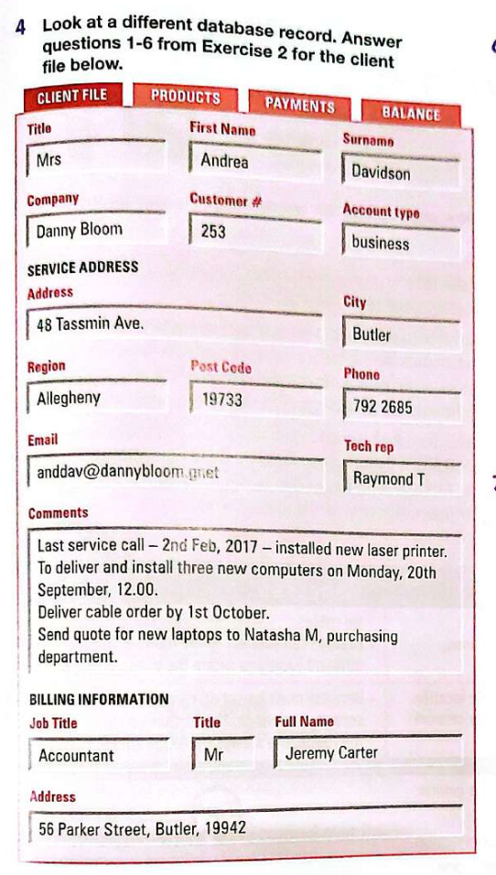

1. What is your company address? 48 Tassmin Ave.
2. Is it a business account or a private account? It is a business account.
3. Where should we send your bills? 56 Parker Street, Butler, 19942.
4. When can we come to install the new computers? On Monday , 20th September at 12:00.
5. When do you require your cable order? By the 1st October.
6. Where should I send the quote for new laptops? To Natasha from purchasing department.

Exercise 5
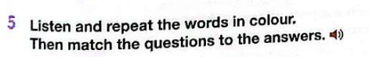

1. What is their service address? → d. D. Jones Accounting Services, PO Box 3198, Hartley
2. What is their post code? → f. Its BL5 NH3
3. Who is the tech rep for Morgan Computers? → e. Frank Bolt
4. What title should I use for Jeff Duncan? → b. Dr
5. What balance have I got on my account? → c. 438.50 pounds.
6. What is the billing address for Select Mobile Phones? → a. 24 Whiting Road, Manley.

Exercise 6
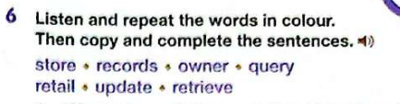

1. Who is the owner of this expensive mobile phone?
2. That app isn’t compatible any more. You need to update it.
3. I can’t help you unless you tell me where you usually store these documents.
4. According to our records, you placed your last order in March.
5. Electronics for All is a retail business in the center of town.
6. I deleted a file by accident. Is it possible to retrieve the documents.
7. You use a query to find specific information in your database, such as how many of your customers live in a certain town.

Exercise 7
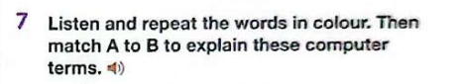

1. Classification means → b. to separate items into specific categories.
2. Null means → c. nothing, it’s an object of no worth.
3. A schema is a description → e. the structures and rules to make a database
4. A field is a specific area → f. in a form where you input data.
5. Criteria are parameters → a. you set for a query.
6. Inserting a cross-reference allows you to → d. link to other parts in the same document.

